Students: Andrew-Nicholas Rusu, Patrick Bucioaca
Date: September 26th, 2026
Class: .NET Development
Teacher: Reza Mirsalari
All Reporting of C# Basic Types, Strings, & Nullable (Assignment 5)
- The Member class and selected data types:
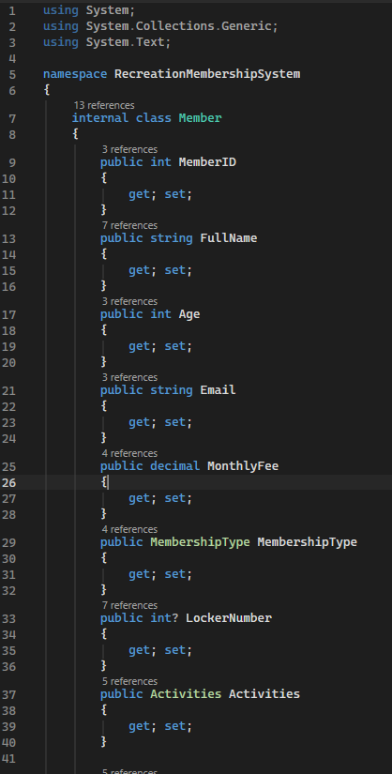
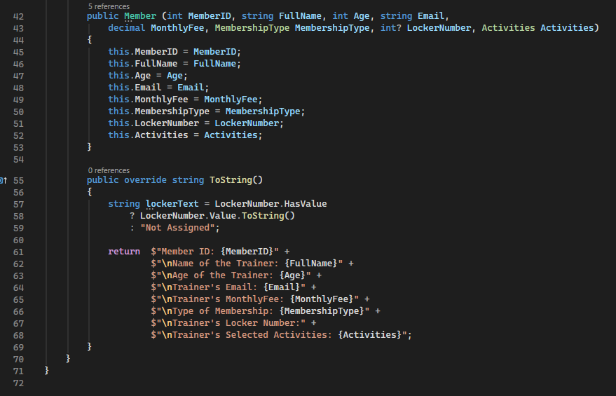
- Regular and [Flags] enums:
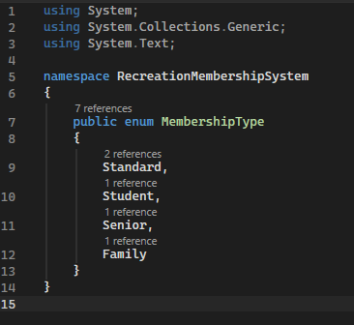
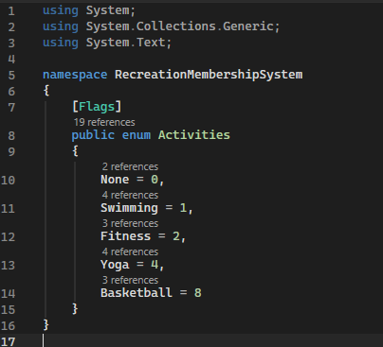
- Nullable locker implementation:
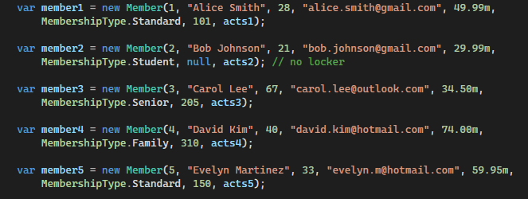
- String processing:
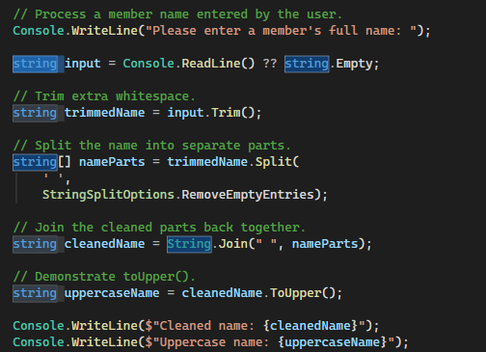
- Flag operations:
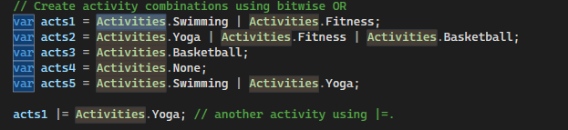

- StringBuilder:
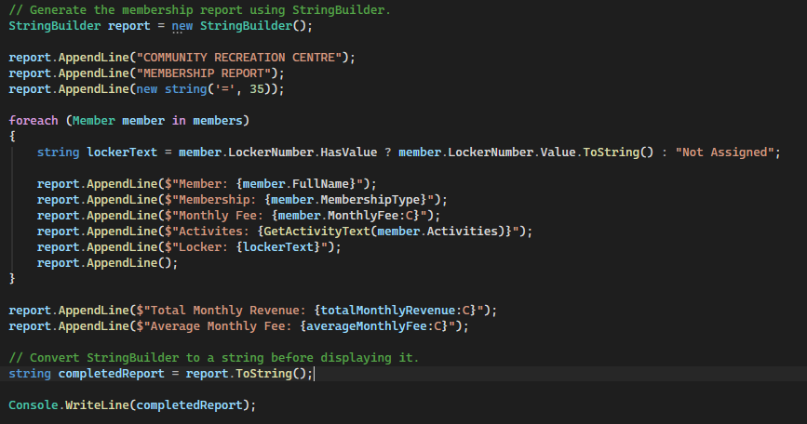
- Calculations:
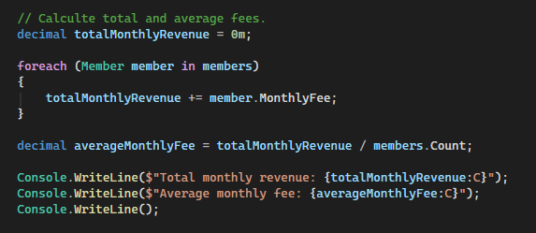
- Successful build and final application output:
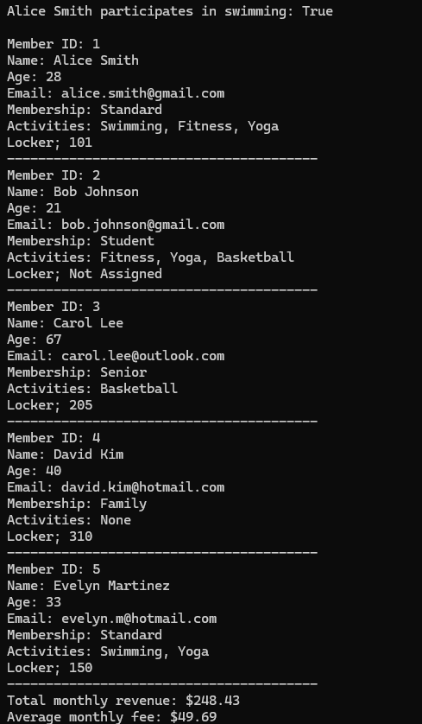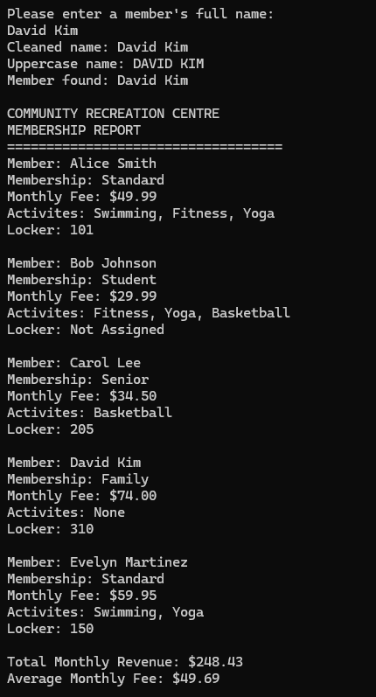

AI Disclosure:
I used AI to help me create Flag attributes because I couldn’t understand the difference between them and the normal attributes. I also used it to help debug the code in order for me to explain the more complex structures and how they are used throughout the code.

